**Head to Toe Skin Check completed**: □ Yes □ No / **Skin Integrity**: □ WNL/Intact □ Not Intact (Describe Below)

**Skin Folds & Under Breasts clear**: □ Yes □ No / **Skin Color**: □ WNL □ Pale □ Dusky □ Cyanotic □ Jaundice □ Other (describe):

**Temperature**: □ Afebrile/No Fever □ Warmer than normal (febrile) / **Moisture**: □ WNL □ Dry □ Diaphoretic/Sweating □ Other (describe):

**Wound Type**: □ Bruise □ Skin Tear/Abrasion □ Laceration/Cut □ Rash □ Puncture □ Burn □ Incision/ Surgical □ Other: ______________

**Description of Wound**: ___________________________________________________________________________________________________

**□ Witnessed □ Unwitnessed / Measurement of Wound**: Length: ______ cm □ Width: ______ cm □ Depth (visual estimate): _____ cm

□ **Pressure Ulcer / Staging**: □ 1 □ 2 □ 3 □ 4 □ Unstageable / **Pain**: □ No □ Yes, describe: __________________________________

**Signs/Symptoms of Inflammation/Infection & Surrounding Tissue**: □ Redness □ Tenderness/Pain □ Warmth □ Swelling/Edema

□ Bruising □ Discoloration □ Rash: Describe: _______________________________________________________________________________

**Drainage**: □ Serous (Thin, Watery, Clear) □ Serosanguinous ( Thin Watery, Pale Red/Pink) □ Sanguineous (Bloody) □ Pus/Purulent

□ Yellow/Tan □ Brown □ Green / □ Thick □ Thin / □ Scant □ Small □ Moderate □ Large / **Foul Odor**: □ Yes □ No

**AFH PROVIDER NOTIFIED ON: Date/Time: _______________________ BY: _________________________________________________**

**PCP: ___________________________________ FAXED TO PCP ON: Date/Time: _______________________ New Orders? □ Yes □ No**

**FAMILY/POA WHO WAS NOTIFIED: __________________________________________________ Date/Time: _______________________**

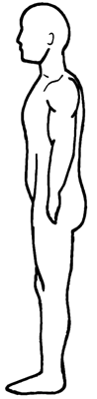 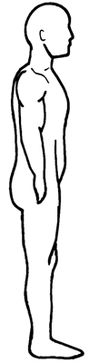 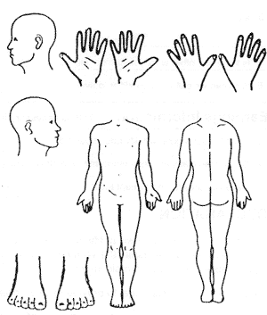 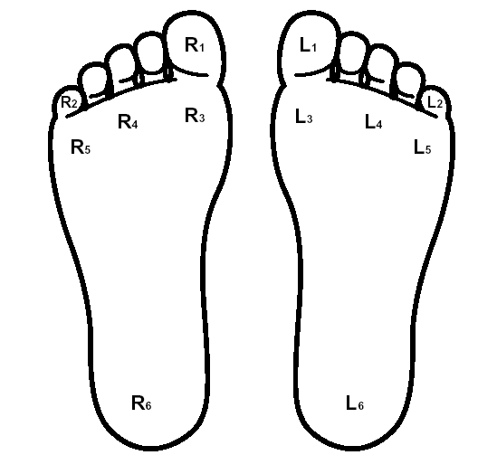

**Notes:** ________________________________________________________________________________________________________________________________________________________________________________________________________________________________________________________________________________________________________________________________________________________________________________________________________________________________________________________________